**A spotlight on enjoying D.C.’s independent galleries**

By Caroline Cliona Boyle

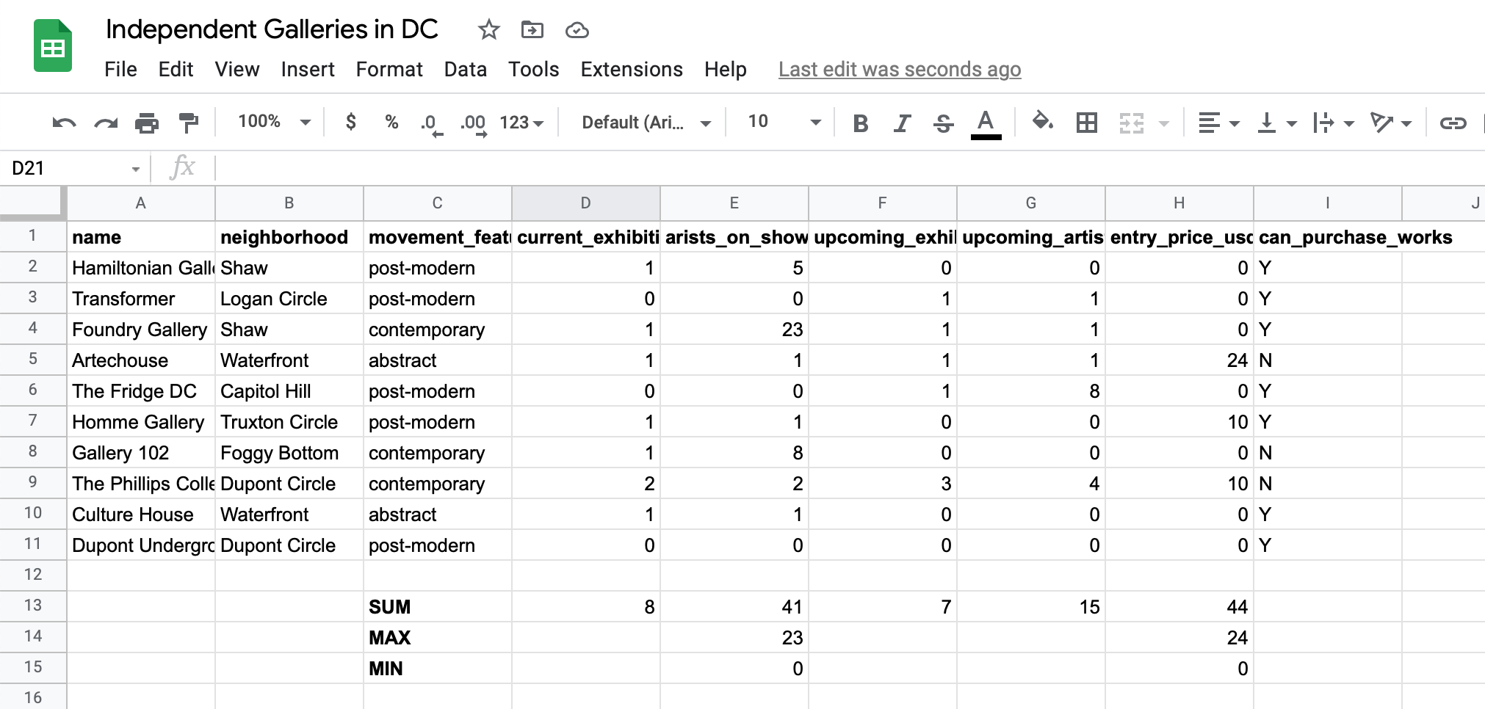

LINK TO GOOGLE SHEETS: <https://docs.google.com/spreadsheets/d/1ZJo88EsrkyaBvIh6_VLO_sKOOdB6wc0OKqT_Mxqq63s/edit?usp=sharing>

When people think enriching art experiences in DC, their mind probably gravitates toward the Smithsonian museums that are interspersed throughout the city. These museums, in addition to being mostly free, sit at the cultural center of tourism in the District. What’s lesser known about D.C.’s art scene is the abundance of smaller independent galleries that feature the works of local contemporary artists.

These galleries, including Hamiltonian Artists, Transformer, and Gallery 102, are both affordable to visit, and offer an opportunity to connect with creatives who are influenced by the diverse community around them. While the most common areas that these particular galleries are located are Dupont Circle, Shaw, and the Waterfront, these cultural institutions are spread out throughout the city. Out of a selection of 10 independent galleries to visit in Washington, there are currently **eight exhibits** that feature the works of **a total 41 artists**.

The galleries transcend theme and genre in the contemporary space. **Five of the exhibits feature the works of artists operating in a post-modern atmosphere, three galleries focus solely on contemporary art, while two specialize in abstract art.**

If you want to take a tour of all of the galleries featured in this selection of independent spaces, it will **cost a total of $44**. However, there is a range of prices between the galleries, with many of the galleries costing nothing to indulge in a fruitful artistic experience, with others **costing upwards of $24 for an entry ticket**.

While the art is on display for the enjoyment of all, it is possible to commission the works of the artists at **7 out of the 10 galleries**. When the shows of the current exhibitions close, look forward to enjoying the **works of 15 artists** at **7 upcoming exhibitions.**